6. BRAKES
BRAKES: It’s machine member used either to reduce the motion of machine or to bring the machine to rest.
Mechanical Energy Consumption | KE Consumption | Friction (Brakes) is applied and heat is generated. E.g.…Case of Flat surface and inclined surface.
 | PE Consumption
SHOE BRAKES:
P = Applied Load on operating lever,  R = Reaction between friction lining and rotating wheel,  l = Shortest distance between the Line of action of ‘P’ and fulcrum ‘O’,  a = Shortest distance between the Line of action of ‘R’ and fulcrum ‘O’, | b = Shortest distance between the Line of action of ‘F’ and fulcrum ‘O’,  2θ = Angle subtended by shoe at centre,  Applied moment = Pl (Clockwise)  Reaction moment = Ra (Anti-Clockwise)
Non-Self Energising Shoe Brake:  Friction Force F = μR (Leftward on lever and Rightward on Wheel)  Additional moment = Fb (Anti-Clockwise)  If there is no additional moment in the direction of applied moment, the brake is said to be Non-Self Energising Shoe Brake.  At equilibrium Sum of moments at ‘O’ = 0  $$R= {Pl}/{(a+μb)}$$  Braking Torque = F r_{d} = μR r_{d} , Where r_{d} = Radius of wheel |  | 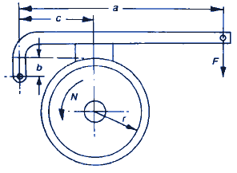
Self-Energising Shoe Brake:
Friction Force F = μR (Rightward on lever and Leftward on Wheel)
Additional moment = Fb (Clockwise)
If there is additional moment in the direction of applied moment, the brake is said to be Self-Energising Shoe Brake.
At equilibrium Sum of moments at ‘O’ = 0
$$R= {Pl}/{(a-μb)}$$
Braking Torque = F r_{d} = μR r_{d} , Where r_{d} = Radius of wheel
Self-Locking of Shoe Brake: It’s extreme condition of self-energising brake.
At without Applied Load on operating lever (P = 0), Braking is present.
This effect encounters by extreme wear of brakes. Useful in Cranes.
Hence, limiting Condition for Self-Locking => a = μb
Equivalent Co-efficient of friction (μ’):
Uniform Pressure condition => 2θ ≤ 45° => Short Shoe => Braking Torque = F r_{d} = μR r_{d}
Uniform wear condition => 2θ > 45° => Long Shoe => Braking Torque = F r_{d} = μ’R r_{d}
Where, $μ’= \frac{4 μ\sin{θ}}{2θ+\sin{2θ}}$
SIMPLE BAND BRAKES: One end of band is connected to operating lever and another end to fulcrum.
$$F=T_{1}-T_{2}$$  $$\frac{T_{1}}{T_{2}}=\frac{P_{max}}{P_{min}}= e^{μθ}$$  $$P_{max}= \frac{T_{1}}{r_{d}w} , P_{min}= \frac{T_{2}}{r_{d}w}$$  Braking Torque, $T_{b}=(T_{1}-T_{2})r_{d}$  Simple Band Brake is never self-energising brake. | F = Total Friction Force,  T1= Tension on Tight Side,  T2 = Tension on Slack Side,  θ = Angle of wrap,  P_{max} = Maximum radial pressure due to normal reaction force on element  P_{min} = Minimum radial pressure due to normal reaction force on element  w = Width of band | 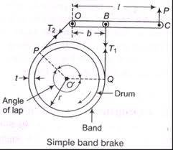
DIFFERENTIAL BAND BRAKES: No end of band is passing through fulcrum.
$$\frac{a}{b}≤ \frac{T_{1}}{T_{2}}≤ \frac{b}{a}<1$$  Both direction of rotation of brake It’s self-energise but only in one direction of rotation it’s self-locking.  Correct Sequence: b-O-a (b-L) | 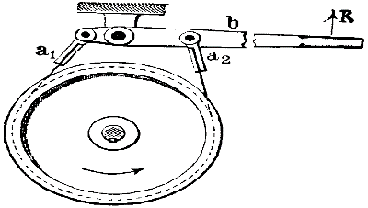
BAND-BLOCK BRAKES:
Braking Torque,  $$T_{b}=(T_{1}-T_{2})(r_{d}+t)$$  $$\frac{T_{1}}{T_{2}}= {\left[\frac{1+μ\tan{θ}}{1-μ\tan{θ}}\right]}^{n}$$ | 2θ = Angle subtended by shoe at centre,  P = Applied Load on operating lever,  T = Reaction Force,  n = No. of shoes, | r_{d} = Radius of wheel,  t = Thickness of shoes,

